

**PNP Camp Crame Sports Center Reservation System**

Almuete, Mark Ferdinand

Ramit, Jericho Marvin

Seagan Kathleen

Submitted to: Ms. Rhea-Luz Valbuena

Table of Contents

I. Project Overview 3

II. Purpose 3

III. Objectives 4

IV. Related Literature Software 4

V. Organizational Chart 6

a. Client 6

b. PNP Camp Crame Sports Center 7

c. Team 8

VI. Roles and Responsibilities 9

VII. Costs and Benefits 10

VIII. Constraints and Limitation 10

IX. Risk Management 11

XI. Diagrams 15

a. Use Case 15

b. Class Diagram 20

c. Sequence Diagram 21

d. State Transition 29

e. Activity Diagram 30

f. Functional Decomposition Diagram 37

g. Context Flow Diagram 38

h. Data Flow Diagram 39

Level0 39

Level 1 40

i. Entity Relationship Diagram 43

j. Component Diagram 44

k. Package Diagram 45

l. Deployment Diagram 46

XII. Resume 47

# **Project Overview**

PNP Camp Crame Sports Center is composed of different facilities that can be used as a venue for sport activities and events. Reservation of the facility is open for all. Currently, customer wants to reserve a facility in the Sports Center, they have to create a request letter, and then have to wait for the approval. Due to that reasons, the developers of this project were assigned to integrate a website and a system that will bring improvement to the business to run smoothly and efficiently.

 The existing process of transaction seemed difficult, before, Support Service Unit (SSU) has to spend money for printing documents or other requirements and because of the large volume of papers used for processing the reservation request, problems occurred such as data redundancy, lack of storage space, and slow access to records. This present some problem for the office, like the occurrence when manually encoding data.

 Using the PNP Camp Crame Reservation System, the reservation process will become more convenient, faster, and useful to their customers, management, and also for the client. It helps the client to reserve the facilities without going straightaway to the sports center. And lastly, only the management are the ones that can monitor all the transaction of their customers.

# **Purpose**

• Improve Service   
  - The reservation system is accessed online for the reservation convenience of the customers.

• Better Performance  
  - The processing of customer reservation request aims to be reduced from 14 days to the average of 7 - 3 days. eliminate the excessive use of papers in the transactions. A database will keep track of the information and transactions. Computerized documents with search function will lessen the searching and processing time of the documents.

• Reduced Cost   
 - The system aims to eliminate the excessive use of papers in the transactions. A database will keep track of the information and transactions.

• Stronger Controls   
  - The personnel can view the availability and status of the facilities through the website in real time. They can view the payment status as well as the status of the requests. It will avoid certain problems such as unpaid reservations and incomplete requirements of the customers.

# **Objectives**

**General objectives**   
  • To provide the PNP Camp Crame a website that promotes new technologies.   
  • To create a system that can help lessen paper works for reservation.   
  • To provide customer an efficient way to reserve a facility.   
  • To provide customer a faster tracking of reservation.   
  
**Specific objectives**   
  • To decrease the daily face to face reservation by 80%   
  • To decrease the processing time from 14 days to 3-7 days.  
  • To increase the tracking of documents by 90%

  • To increase the convenience of PNP Sports Center customer by 80%   
  • To have real time information about availability of the facilities by 90%   
  • To increase the access of reservation on the database by 90%   
  • To monitor and track down what facilities that has a lot of number of reservations by 70%

# **Related Literature Software**

**Gym Master**    
  Gym Master reservation system is cloud-based software that is designed to maximize business productivity in any types of gym, from any device. The system can generate 24/7 access control and it also includes prospect management, member portal, point of sale, bookings, and much more. Gym Master offers a complete membership software solution.  The following are the functions of Gym Master that can help the developers implement the system: (1) Providing 24/7 access: it is an automated access control system that provides a convenient way for the client to manage access the facilities that remains working even when they are not. (2) Customer Management: one of the features of Gym Master is their database that stores all the information of their clients, it is also a highly configurable software that designed only for their customers. (3) Booking and Scheduling: one of the highly flexible and easily configurable part of Gym Master’s system is their booking and scheduling module. Because, Gym Master has a lot of features, one of this is that costumers can manage all their activities and reservation, and keeping in contact with their members by automatically communicate them by sending an SMS or email to remind or notify them of their reservations, and. (4) Website Integration: one of the module of their system is that members can reserve and cancel bookings all within parameters of management control. (Retrieved on November 2, 2016 from <https://www.gymmastersoftware.com/about/>)

**PHP**  
  PHP can be used on all major operating systems, including Linux, Microsoft Windows, Mac OS X, and etc. PHP is supporting for most of the web servers today. This includes Apache, IIS, and many others. So, with PHP, you have the freedom of choosing an operating system and a web server because on PHP you are not limited to output HTML. PHP's abilities for outputting are including images, PDF files and any text such as XHTML and any other XML file. PHP can auto generate these files, and save them in the file system. One of the strongest and most significant features in PHP is its support for a wide range of databases. Writing a database-enabled web page is incredibly simple using one of the database specific extensions (e.g., for MySQL), or using an abstraction layer like PDO, or connect to any database that are open connection. (Retrieved on November 2, 2016 from <https://en.wikipedia.org/wiki/PHP> )

# **Organizational Chart**

## **Client**

Organizational Chart of Special Service Unit (SSU)

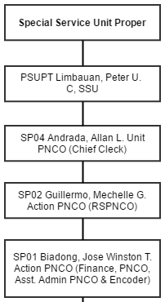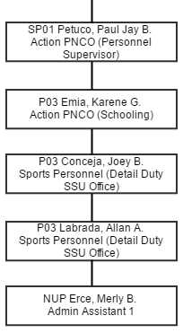

## **PNP Camp Crame Sports Center**

Organizational Chart of PNP Sports and Facilities Section (SFS)

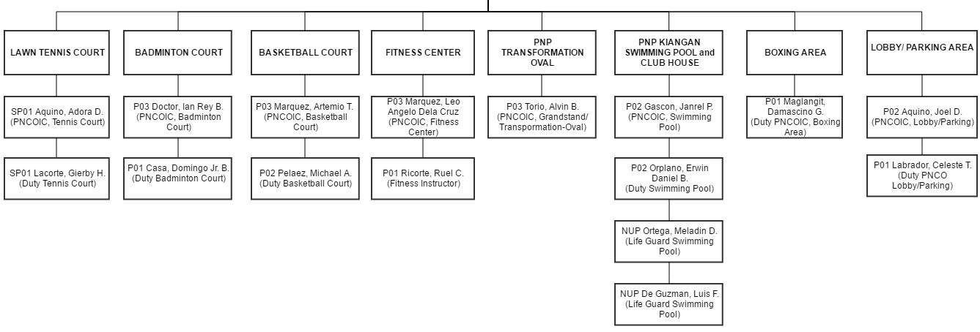

## **Team**

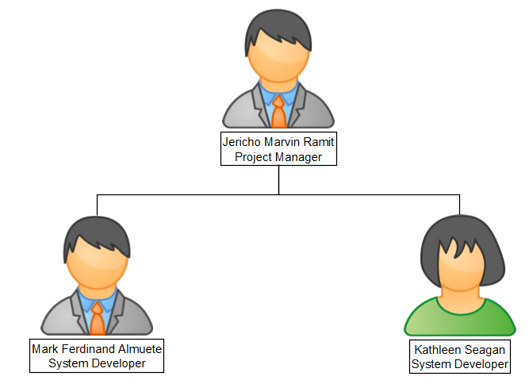

# **Roles and Responsibilities**

|  |  |  |  |  |
| --- | --- | --- | --- | --- |
| **Roles** | **Responsibilities** | Jericho Marvin Ramit | Mark Ferdinand Almuete | Kathleen Seagan |
| Project Manager | * Make sure that all the plans are well-organized * Assign to schedule a group meeting * Give task to every member of the group * Monitor the progress of the project * Sign the weekly project status report * Schedule meeting with the consultant every Tuesday * Set meeting with the client | ✓ |  |  |
| System Analyst | * Partly for developing diagrams and project prototype * Ensure the needs and expectations of the client * Analyze and understand the current state processes | ✓ | ✓ | ✓ |
| System Developer | * Developing the Website * Maintain and improve the system * Test the system made by the system designer * Analyze client requirements * Developing new system * Monitor the software defects | ✓ | ✓ | ✓ |
| System Designer | * Consulting clients and system analyst about required * Produce design that suits the Website * Implement the new system * Test it to ensure that the it operates reliably | ✓ | ✓ | ✓ |
| System Documentator | * Document what the group talked about in meeting * Make sure that the grammar, spelling and the content is correct * Must create the weekly project status report * Update Wiki | ✓ | ✓ | ✓ |

# **Costs and Benefits**

|  |  |  |
| --- | --- | --- |
|  | **Cost** | **Benefit** |
| **Tangible** | * Salaries of the analyst, programmer, designer and developer. * Costs for trainers * Cost for Personal Computer: Php 12,198.00, Digital Age AMD A4 6300 Home and Office Computer Package from www.lazada.com.ph * Cost for web site hosting Php 206.59 per month via Economy Package of GoDaddy.com Philippines * Cost for internet access is Php 999.00 per month via PLDT Home DSL * Cost of the website is Php 293,850.00 based on the following:   - 10 to 50 number of pages  - a simple yet attractive style of design  - basic database integration | * Increase the income of PNP Sports Center * Reduce error * Improve Service * Better Performance * Reduced Cost * Stronger Controls |
| **Intangible** | * Cost for maintenance * Incremental data storage expenses * Customer, employee and loss of potential customer | * Meeting client’s expectations to have a web site * Improvement of the reservation request process * Not having to go to SSU Department for reservation * Feedback from customer on facility |

# **Constraints and Limitation**

The focus of the project is to improve the current reservation system of PNP Camp Crame Sports Center and create a system where the customers can create an account to reserve the facilities in sports center through website. After the customer creates an account, customer can view all the information of the facilities like availability, price, and status of the facility. After viewing the facility, the details of other customers are not included in the information.  The purpose of the system is to serve as a database that will save information about the customers, the employees, the reservation procedures. In terms of user access, only the management can access the system which means that the management is the only one who has the control to update and delete data. While the customers can only create his or her account and make reservation through the facility’s website. Only SSU in-charge personnel can cancel a reservation if there is lack in the customer’s requirements. Customers can only create and edit his/her account and make reservation.

# **Risk Management**

|  |  |  |  |  |  |  |
| --- | --- | --- | --- | --- | --- | --- |
| **Risk** | **Probability** | **Impact** | **Category** | **Description** | **Mitigation** | **Trigger** |
| Delayed in purchase of computers | This section does not apply | High | Equipment | Purchase or delivery of equipment may be delayed. | * Developers can assist in finding affordable equipment. * The developers can deliver app will be willing to install them when app is delivered. | None |

1. **Software Requirements Specification Checklist**

|  |  |  |  |  |
| --- | --- | --- | --- | --- |
|  | ASSIGNED TO | YES | NO | REMARKS |
| **Output**  ✓ The Web site must have service/s offered.  ✓ The system must display all the scheduled date of the maintenance of the facilities.  ✓ The user can see all the past events, pictures of facilities, and trainer in the sports complex.  ✓ The user can see the calendar that displays the schedule of the reservations  ✓ The Web site must provide the total reservation fee for each facility  ✓ Prompt the customer that the approval letter can be send through email  ✓ The system must produce a monthly report showing date of reservation, facility, type of event, arrival time, and departure time of all sorted by date of reservation.  ✓ Background color of the website must be uniform. | Ramit  Ramit  Seagan  Ramit  Ramit  Seagan  Almuete  Ramit |  |  |  |

|  |  |  |  |  |
| --- | --- | --- | --- | --- |
| **Input**  ✓ The client and user can create an account and log in.  ✓ The user can login to the system  ✓ The user can choose the date of reservation.  ✓ User must input the date, time of reservation | Ramit  Seagan  Almuete  Ramit |  |  |  |
| **Process**  ✓ The system must compute the overall bill of client for reserving a facility  ✓ The system can record all the data that is inputted by the user  ✓ The user can reserve facility in the Web site.  ✓ The management records system must calculate the total amount of the reservation fee at the end of week.  ✓ The system must update the availability status of the facilities | Almuete  Ramit  Seagan  Almuete  Ramit |  |  |  |

|  |  |  |  |  |
| --- | --- | --- | --- | --- |
| **Performance**  ✓ The system must support 25 or more users online simultaneously.  ✓ Response time must not exceed four seconds.  ✓ The system must be operational 24/7.  **Control**  ✓ The system must provide logon security at the operating system level and at the application level.  ✓ A customer record must be added, changed, or deleted only by a member of the SSU department.  ✓ The system must create an error log file that includes the error type, description, and time.  ✓ User can cancel the reservation.  ✓ The user cannot open their account if the inputted password is not correct,  ✓ The availability status of the facilities cannot be viewed by the users if they still don’t have an account  ✓ The user cannot reserve a facility that is not available that time  ✓ The system can track all the client reservations that have incomplete content in the letter of request | Ramit  Almuete  Seagan  Ramit  Almute  Seagan  Ramit  Seagan  Seagan  Ramit  Almuete |  |  |  |

# **Diagrams**

The figure below is the list of processes from creation of account up to cancelation of reservation of the customer.

## **Use Case**

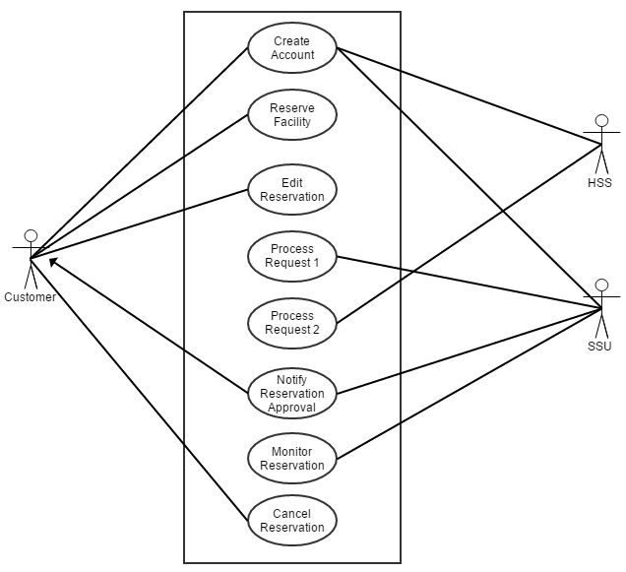**Diagram**

**Narrative**

|  |  |
| --- | --- |
| Use Case: | Create Account |
| Actor: | Customer |
| Description: | Customer creates an account to the website |
| Successful Completion: | 1. Customer access the website 2. The website prompts the customer to create an account 3. The customer fills up the registration form 4. The customer accepts the terms and condition 5. The website verifies the sign up of the customer 6. Website creates an account of the customer 7. Customer gains access to the website |
| Alternatives: | 1. Customer does not accept the terms and conditions    1. Website displays a message showing that he/she must accept the terms and conditions 2. Customer clicks/taps the “Register Account” button without accepting the terms and conditions   2.1 Website goes back to registration form screen and message shows that he/she must accept the terms and condition |
| Pre-Condition: | None |
| Post Condition: | Customer’s account has been created and verified |
| Assumption: | 1. Customer needs to create an account if he/she does not have existing 2. Customer must fill up all the fields in the registration form 3. Customer must input appropriate password 4. The customer’s account will not be activated unless account is verified. 5. The customer must accept the terms and condition. |

|  |  |
| --- | --- |
| Use Case: | Reserve Facility |
| Actor: | Customer |
| Description: | Customer reserves a facility |
| Successful Completion: | 1. Customer views the availability status of the facilities 2. The website displays the availability of facilities with rates 3. Users chooses available facility to reserve 4. Customer creates a request for facility reservation 5. Website sends the customer’s request to SSU for reserving a facility |
| Alternatives: | 1. Customer reserves a facility by walk-in SSU Department    1. Customer creates letter of request    2. Customer submits the letter of request to SSU Office |
| Pre-Condition: | Customer wants reserve for a facility |
| Post Condition: | Customer’s reservation request will be send to SSU |
| Assumption: | 1. The customer doesn’t know that there is a website 2. The website will no longer shows the log-in page if the customer is already logged in 3. The facility that the customer wants to reserve is available for the requested time of reservation 4. The website will go back to “Reservation” tab, when the customer cancelled the reservation. |

|  |  |
| --- | --- |
| Use Case: | Edit Reservation |
| Actor: | Customer |
| Description: | Customer edits his/her reservation request |
| Successful Completion: | 1. Customer views his/her reservation status 2. Customer edits the reservation request form 3. Customer submits the reservation request form 4. Website updates the reservation request information 5. Website sends the customer’s request to SSU for reserving a facility |
| Alternatives: | None |
| Pre-Condition: | Customer reserves a facility |
| Post Condition: | Customer’s reservation request will be send to SSU |
| Assumption: |  |

|  |  |
| --- | --- |
| Use Case: | Process Request 1 |
| Actor: | SSU |
| Description: | SSU received the request of the customer. |
| Successful Completion: | 1. SSU receives the request of the customer 2. SSU views the availability status of the facilities 3. SSU approves the request of the customer 4. SSU creates a request for the customer’s reservation 5. Website sends the SSU’s request to HSS for facility reservation |
| Alternatives: | 1. Customer’s requirements in the reservation request are incomplete or not legit    1. SSU disapproves the reservation request with the stated problem indicated    2. Website deletes the pending reservation request    3. Website notifies the customer about the cancellation of reservation request |
| Pre-Condition: | SSU receives the request of the customer |
| Post Condition: | SSU approves the request of the customer |
| Assumption: | 1. There is a reservation request from a customer 2. Customer’s requirements are complete and legit. 3. Facility is available for the customer’s reservation |

|  |  |
| --- | --- |
| Use Case: | Process Request 2 |
| Actor: | HSS |
| Description: | HSS approves the request of SSU |
| Successful Completion: | 1. HSS receives the request of SSU 2. Website shows the lists of pending reservation requests of SSU 3. HSS approves the request of the SSU 4. HSS records the reservation 5. Website updates the records of reservations 6. Website sends the HSS’ confirmation notice to SSU |
| Alternatives: | None |
| Pre-Condition: | HSS receives the request of SSU |
| Post Condition: | HSS approves the request of SSU |
| Assumption: | 1. There is a facility accessing request coming from SSU 2. SSU approves the customer’s reservation request |

|  |  |
| --- | --- |
| Use Case: | Notify Reservation Approval |
| Actor: | SSU and Customer |
| Description: | SSU notifies the customer about the approval of the facility reservation |
| Successful Completion: | 1. SSU receives an approval from HSS 2. SSU updates the availability status of the facilities 3. Website sends the SSU’s confirmation to the customer 4. Customer receives the reservation confirmation of the SSU 5. Customer proceeds to the reservation |
| Alternatives: | None |
| Pre-Condition: | SSU and HSS approves the reservation request |
| Post Condition: | Customer reserves a facility |
| Assumption: | 1. HSS approves the customer’s reservation request. |

|  |  |
| --- | --- |
| Use Case: | Monitor Facility |
| Actor: | SSU |
| Description: | SSU monitors the availability status of the facilities |
| Successful Completion: | 1. SSU views the website’s calendar with facilities’ reservation status 2. Website displays the availability status of the facilities 3. SSU updates the availability status of the facilities 4. Website changes the availability status of the facilities |
| Alternatives: | None |
| Pre-Condition: | Customers reserve facilities |
| Post Condition: | The facility status has been updated |
| Assumption: | 1. HSS approves the customer’s reservation request. 2. There is an update on availability status of the facilities |

|  |  |
| --- | --- |
| Use Case: | Cancel Reservation |
| Actor: | Customer and SSU |
| Description: | Customer wants to cancel the facility reservation |
| Successful Completion: | 1. Customer views his/her reservation status 2. Customer cancels the reservation 3. Website processes the cancellation of reservation 4. Website notifies SSU about the cancellation 5. Website updates the availability status of the facilities |
| Alternatives: | None |
| Pre-Condition: | Customer reserves a facility and want to cancel the reservation |
| Post Condition: | Website deletes the customer’s reservation request |
| Assumption: | HSS approves |

## **Class Diagram**

PNP Camp Crame Sports Center needs an improvement in reserving the facilities by creating a reservation system. In the past, a paper record was maintained, but now computers have replaced the old-fashioned approach. This class diagram outlines which objects are present in a reservation process, and depicts exactly how they interface with each other. You'll see classes for reservation request, approval request, billing, facility, equipment, customer and employee.

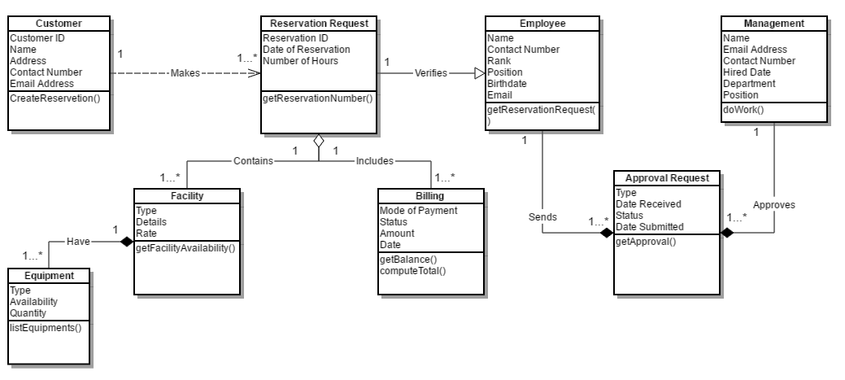

## **Sequence Diagram**

The figure below shows the process on how the customer interact to the system and how the system responds and interacts to the interactions of the customer while creating an account.

**Create Account**

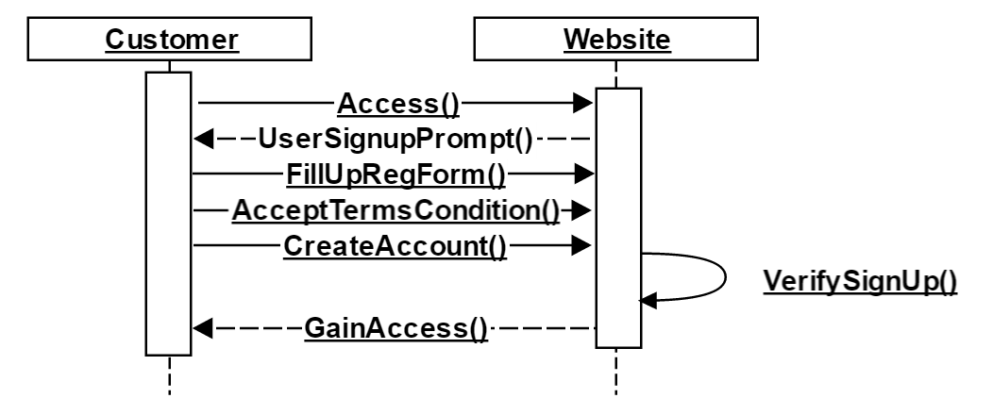

The figure below shows the process on how the customer interact to the system when viewing the availability of the facility and how the system responds by updating the system so that the customer can choose the facility that will be sent to the SSU.

**Reserve Facility**

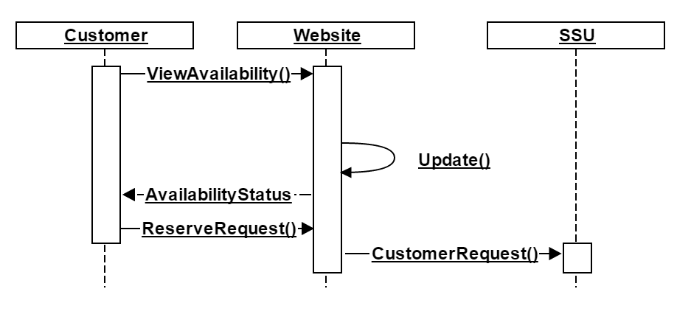

The figure below shows the process on how the system interact to customer when they want to have changes in their reservation like reserved dates or facility. The system need to update the status of facility once it process.

**Edit Reservation**

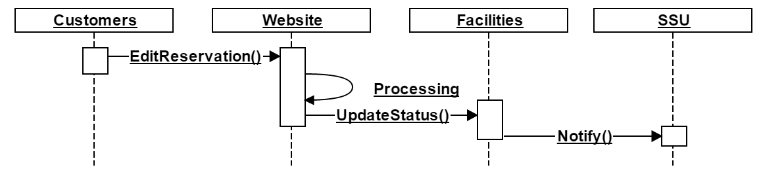The figure below shows the process on how the system interact to SSU when there is a request from the customer. The SSU will approve the request through the system and will create another request for HSS approval.

**Process Request 1**

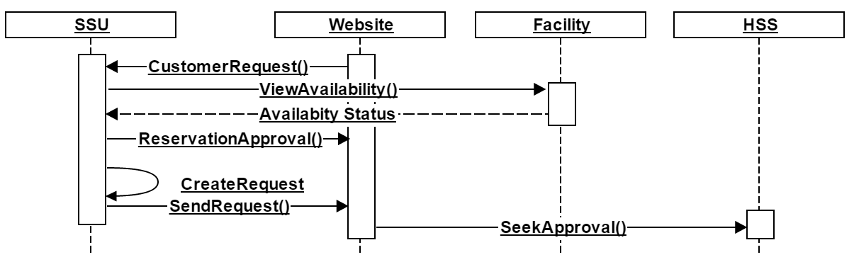

The figure below shows the process on how the system interact to HSS when there is a request coming from SSU and will approve the request through the system. The system will automatically record it and a confirmation notice will be send to SSU.

**Process Request 2**

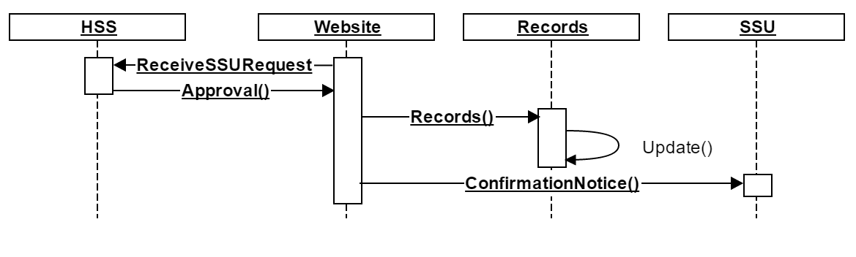

The figure below shows the process on how the system interact to SSU when the confirmation of the reservation is received and SSU will update the status of the facility reserved then SSU will notify the client through the system.

**Notify Reservation Approval**

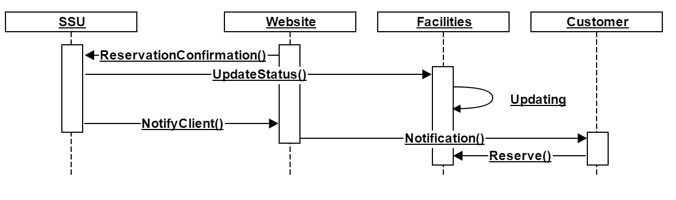

The figure below shows the process of how SSU personnel monitor the facilities' availability status

**Monitor Facility**

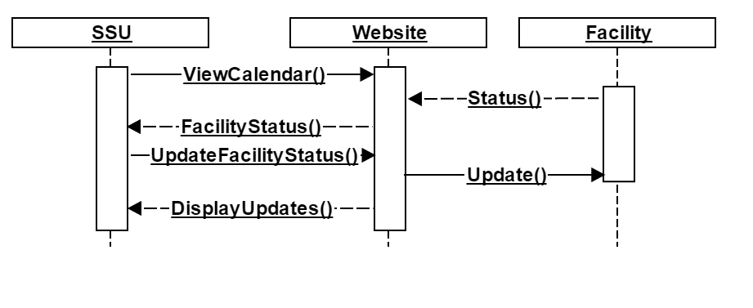

The figure below shows the process on how the customer interact to the system when cancelling the reservation. A notification will send to SSU to inform that the customer is cancelling their reservation then the SSU will update the status of the facility through the system.

**Cancel Reservation**

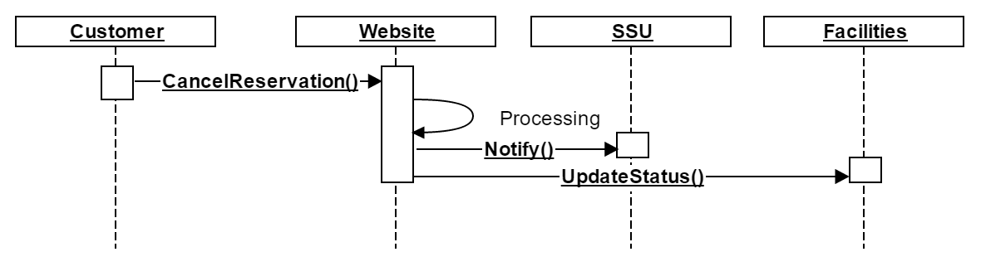

## **State Transition**

**Reservation**

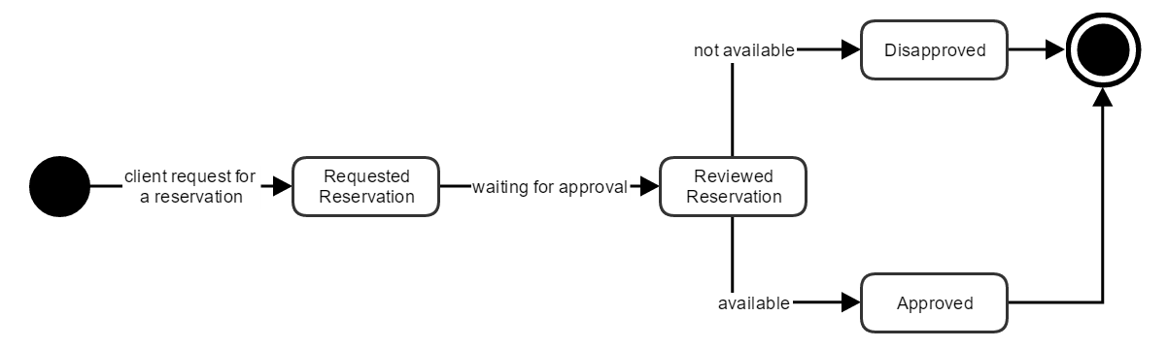

**Facility**



## **Activity Diagram**

**Reservation**

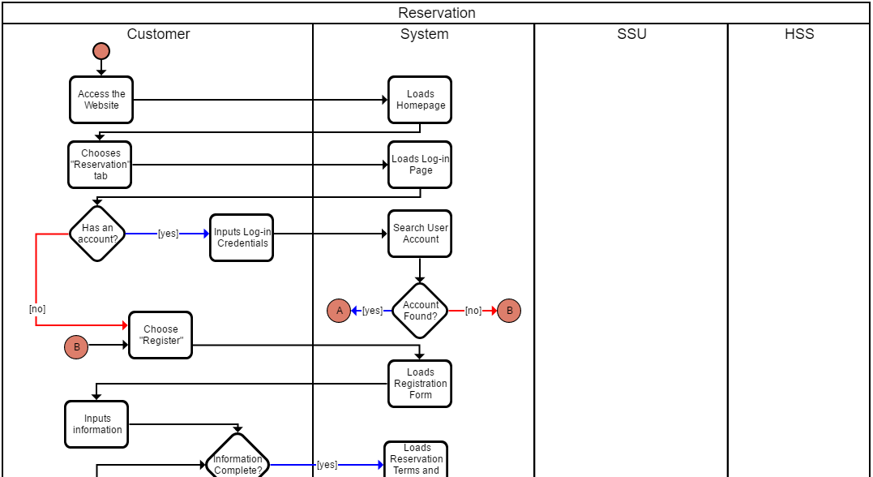 This shows the process of reserving a facility. First, you choose reservation tab after accessing the website. Once you done creating your account or logging the system sends out a verification code in your email. After verifying you choose a facility you want to reserve and choose a date for reservation. To be able to finish reserving you must fill up first the form, submit, wait for the approval then log out.

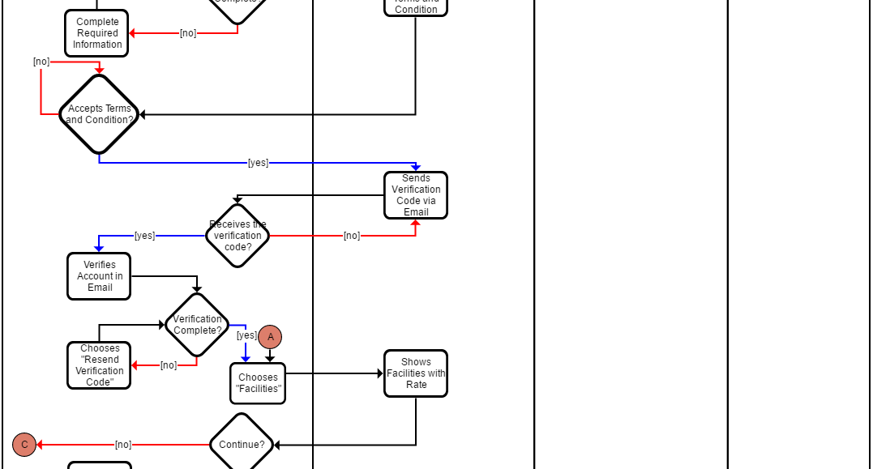

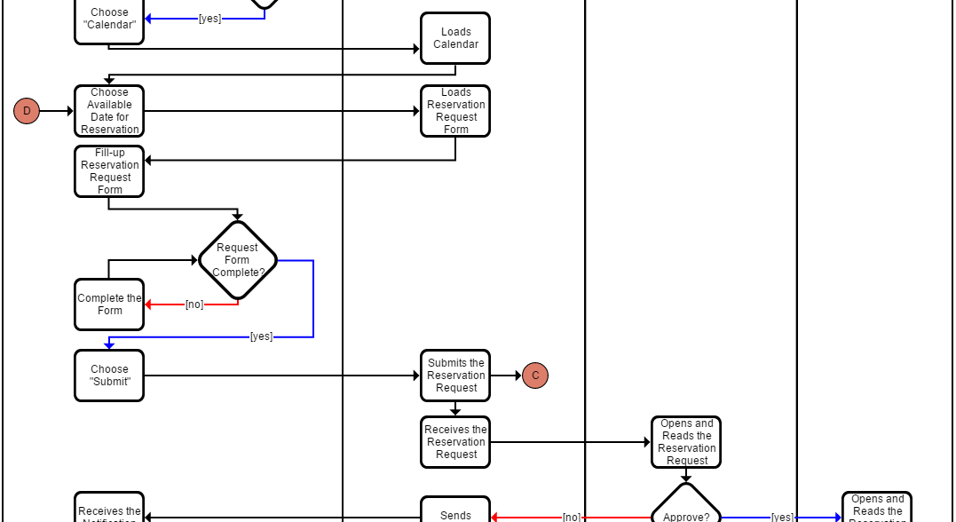

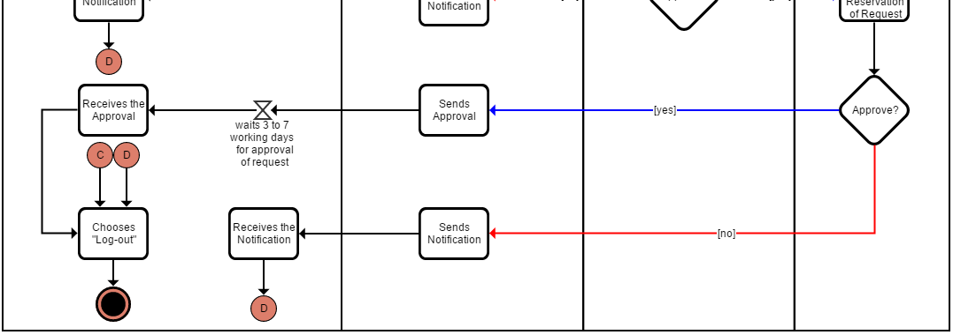

**Cancel Reservation**

This shows the process of cancelling the reservation of facility. First, you must access the website and choose cancel reservation. Once you done cancelling your reservation the system will update the database then your reservation will be cancelled.

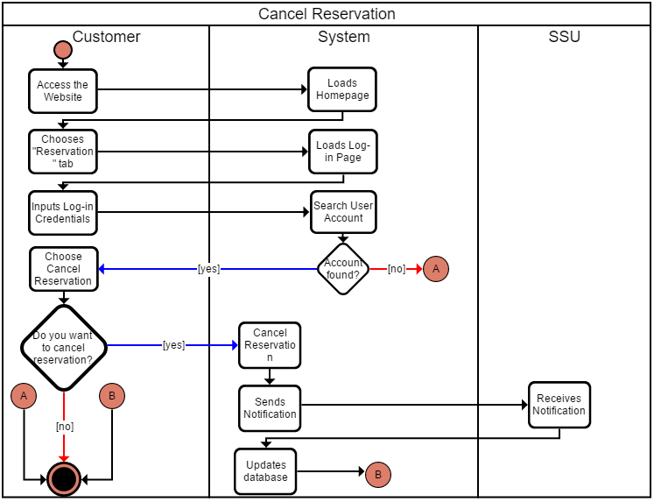

**Time-in**

This shows the process of recording the customer’s time-in. First, you will show the approval of the reservation to the employee to record.

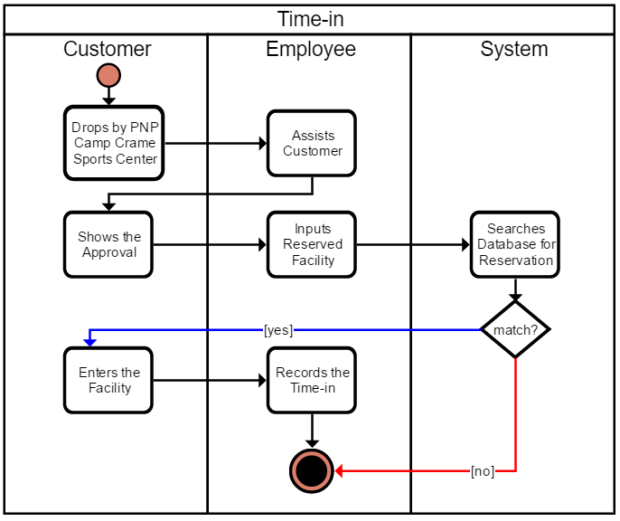

**Time-out**

This shows the process of recording the customer’s time-out. First, you must complete your payment. Once, it is complete the system will update.

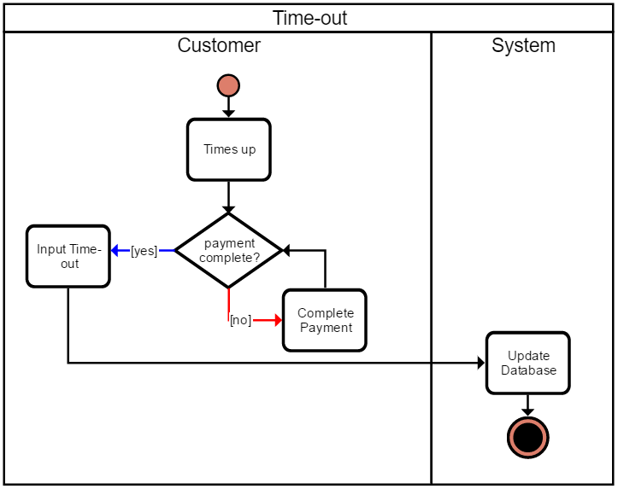

## **Functional Decomposition Diagram**

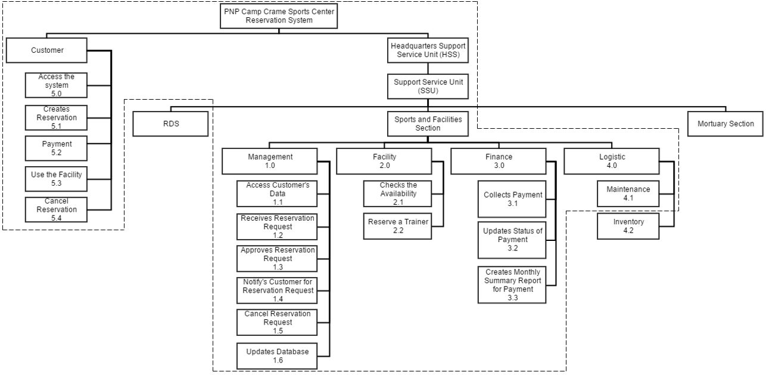

## **Context Flow Diagram**

The figure below shows a context flow diagram that is drawn for Reservation System. It contains process that represents the system to model, in this case, the “Reservation System”. It also shows the participants who will interact with the system, called the external entities. In this case, Customer, Management, and Finance are the entities who will interact with the system. In between the process and the external entities, there are data flows that indicate the existence of information exchange between the entities and the system. It contains only one process and does not show any data store.

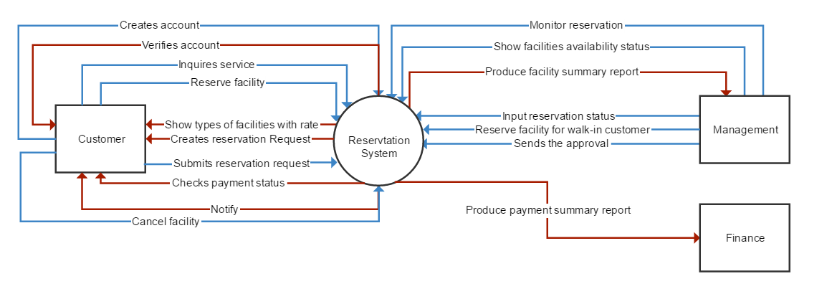

## **Data Flow Diagram**

### **Level0**

The figure below shows the breakdown of Reservation System. The Reservation System contains seven process three external entities and six data store.

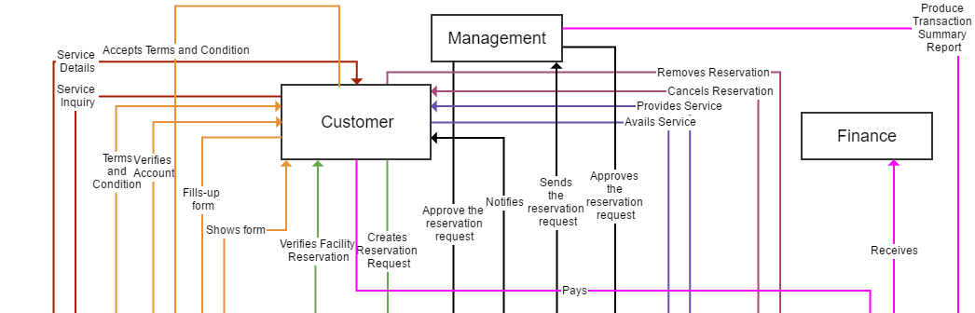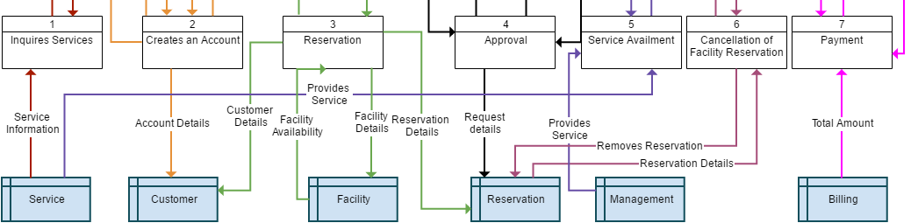

### **Level 1**

**Creates Reservation**

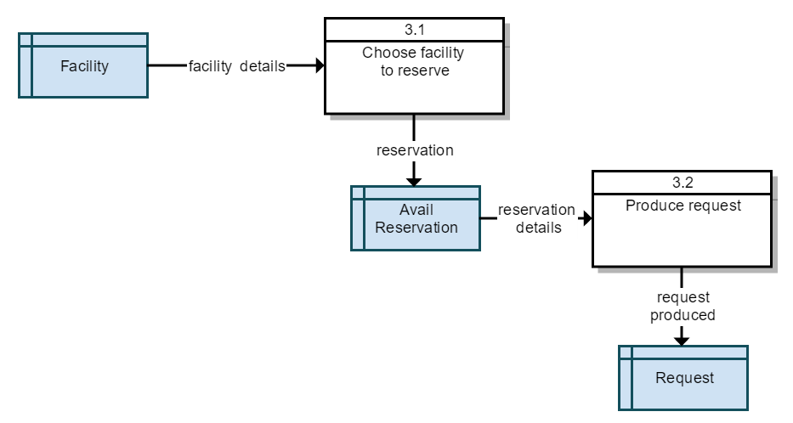

**Approval**

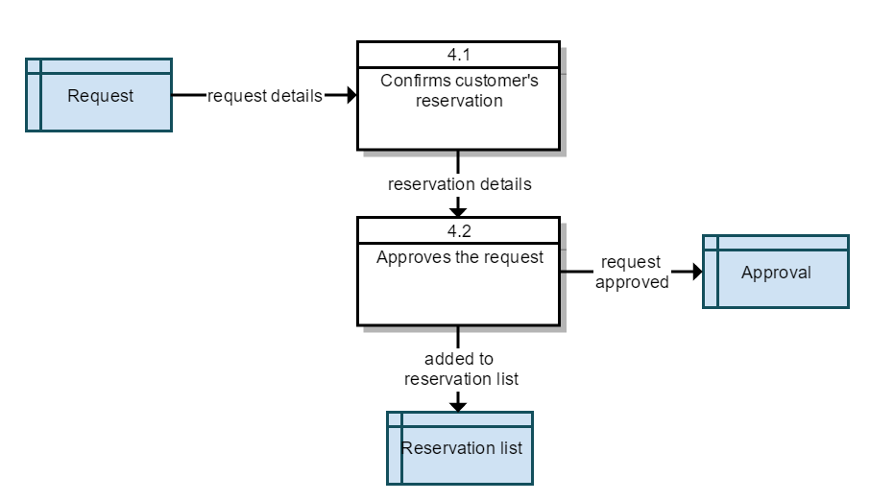

**Cancellation**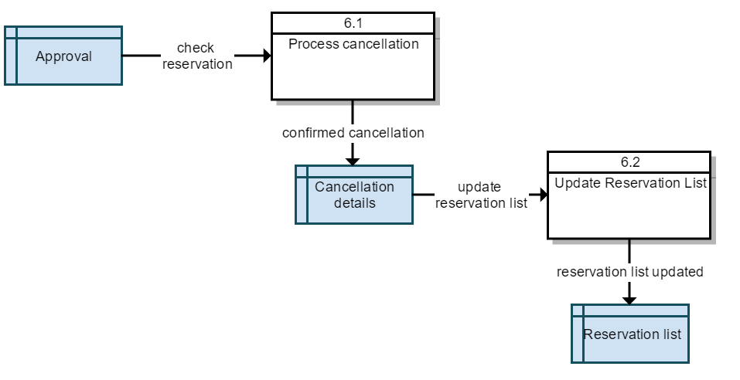

## **Entity Relationship Diagram**

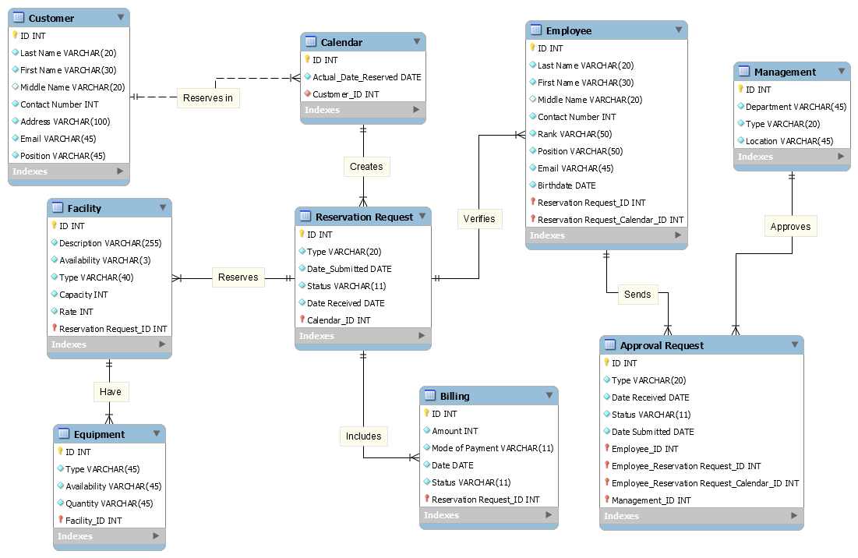The figure below is a representation of entities such as calendar, customer, employee, management, reservation request, billing, approval request, facility and equipment. Then other symbols can be used to represent the relationship between entities, and text used to represent the relationship.

## **Component Diagram**

A component diagram is a diagram that shows the internal structure of a classifier, including its intersection points to other parts of the system. It shows the configuration and relationship of parts, that together, perform the behavior of the containing classifier. Class elements have been described in detail in the section on class diagrams. 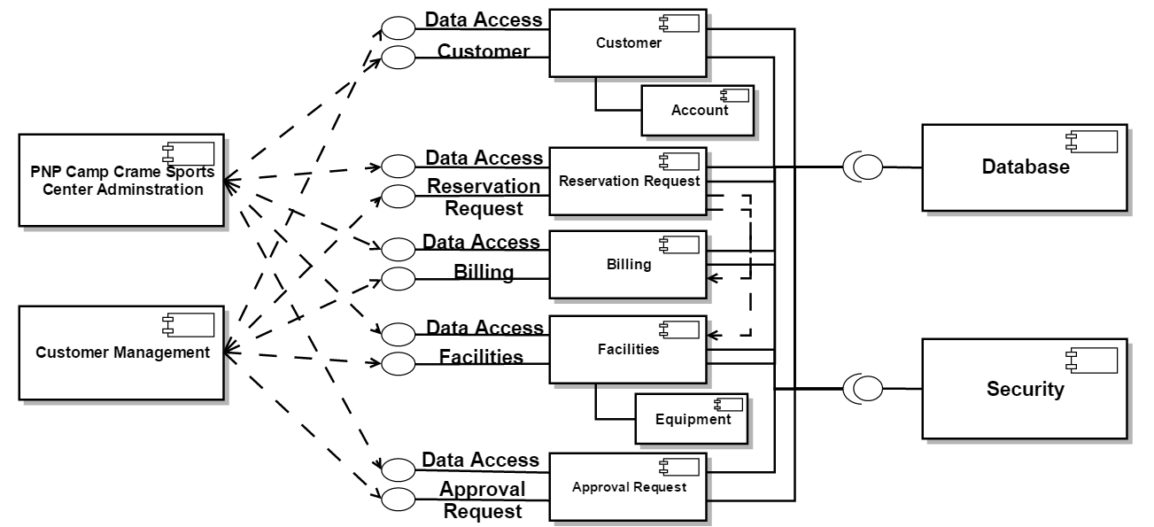

## **Package Diagram**

Package diagram shows the arrangement and organization of model elements in middle to large scale projects. Package diagram can show both structure and dependencies between sub-systems or modules. The diagram below shows two actors which is the customer who reserves for facilities and the management that represents the SSU and HSS departments

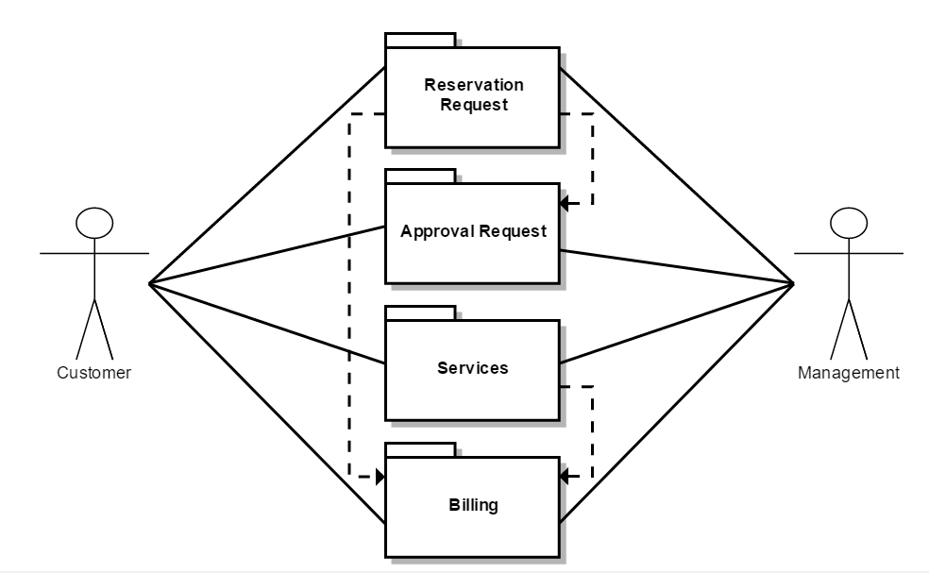

## **Deployment Diagram**

Deployment diagrams are used to visualize the topology of the physical components of a system where the software components are deployed. It also describes the static deployment view of a system. RMI means Java Remote Method Invocation and ODBC means Open Database Connectivity. The system will be developed using PHP programming language, the most popular language for developing web-based systems. The database platform will be used is MySQL.

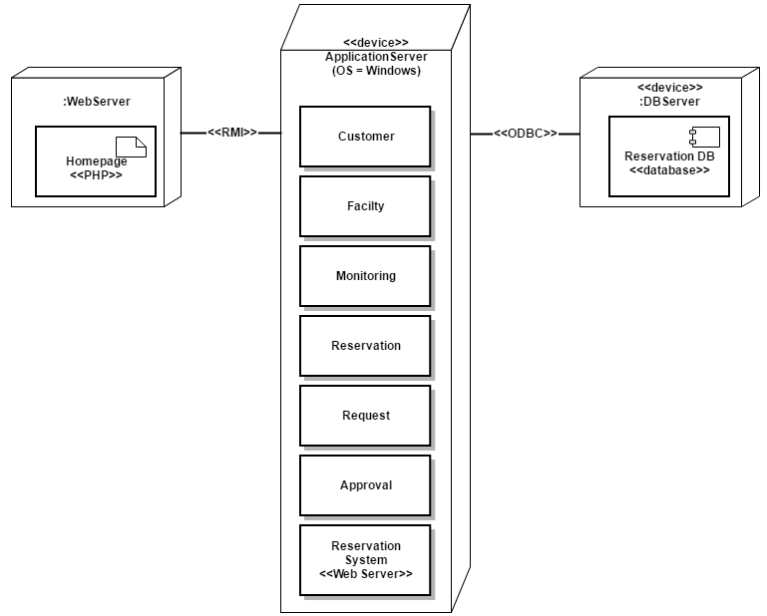

# **Resume**

**MARK FERDINAND ALMUETE**

Central Bicutan, Taguig City  
malmuete@student.apc.edu.ph

09062108861

**JOB OBJECTIVE:**

To succeed in an environment of growth and excellence and earn a job which provides me job satisfaction and self-development and help me achieve personal as well as organizational goals.

**EDUCATIONAL BACKGROUND:**

Tertiary

Asia Pacific College

Magallanes, Makati City

Bachelor of Science in Information Technology

Major in Mobile and Internet Technology

(Undergraduate)

June, 2014 - Present

Secondary

Dr. Arcadio Santos National High School

San Martin De Porres, Paranaque City

2010 - 2014

Primary

Upper Bicutan Elementary School

Upper Bicutan, Taguig City

2004 – 2010

**RELATED SKILLS:**

Professional in Research

Professional in Writing

**CHARACTER REFERENCES:**

Ms. Maya Angelou Sipin 0915 959 8951

maya_sipin@yahoo.com

Ms.Twinkle Morales

0927 545 0334

twinkleM@yahoo.com

Ms. Carmela Flavier

0906-742-5208

CrmlFlvr@yahoo.com.ph

**JERICHO MARVIN M. RAMIT**

Blk. 191 Lot 20 Las Maria St. Pembo, Makati City

echoraldwin@yahoo.com.ph

09174534460

**JOB OBJECTIVE:**

Seeking for position of a web designer to obtain experience and develop my skills, and to build strong relationships with other staff. To obtain a position that will enable me to use my strong organizational skills, educational background and ability to work well with people.

**EDUCATIONAL BACKGROUND:**

**COLLEGE**

Bachelor of Science in Information Technology

Asia Pacific College

#3 Humabon St. Magallanes, Makati City

Anticipated year of Graduation: May 2018

**HIGH SCHOOL**

1STYear - 4THYear

Guadalupe Catholic School

Orense Street Guadalupe Nuevo, Makati City 2010-2014

**ELEMENTARY**

Grade 1 - Grade 6

Pembo Elementary School

Escarlota Street Pembo, Makati CitY

**EMPLOYMENT HISTORY:**

Internship Program

Microsoft Operation

6750 Ayala Avenue, Makati City

June 2017 - December 2017

Mobile and Internet Specialist

**INTEREST AND ACTIVITIES:**

**ORGANIZATION**

Theatre Phileo

@Asia Pacific College, Member, June 2015

Junior Philippines Computer Society(JPCS)

@Asia Pacific College, Member, June 2015

Junior Information Security System Association(JISSA)

@Asia Pacific College, Member, June 2015

**HOBBIES/SKILLS**

Programming Computers

Web Designing

Video Making

Dancing

Acting

Writing

**REFERENCES:**

Ms. Maya Angelou Sipin 0915 959 8951

maya_sipin@yahoo.com

Ms.Twinkle Morales

0927 545 0334

twinkleM@yahoo.com

Ms. Carmela Flavier

0906-742-5208

CrmlFlvr@yahoo.com.ph



**KATHLEEN GABION SEAGAN**

Brgy. Ususan, Diego Silang BCDA, Taguig City   
kathleenseagan@gmail.com

09092821896

**JOB OBJECTIVE:**

To succeed in an environment of growth and excellence and earn a job which provides me job satisfaction and self-development and help me achieve personal as well as organizational goals.

**EDUCATIONAL BACKGROUND:**

Tertiary

Asia Pacific College

Magallanes, Makati City Bachelor of Science in Information Technology

Major in Mobile and Internet Technology

(Undergraduate)

June, 2014 - Present

Secondary

Ramon Magsaysay (Cubao) High School

Quezon City, Philippines

2010 - 2014

Primary

Brittany Christian Academy

Quezon City, Philippines

2004 – 2010

**CERTFICATONS:**

Certification of Participation

Computer Security Junior Information Security System Association

October 2015

Certification of Participation

National General Assembly

March 2016

**ORGANIZATIONS:**

Junior Philippine Computer Society  
Member   
Asia Pacific College   
#3 Humabon Place, Magallanes, Makati City

**RELATED SKILLS:**

Professional in Research

Professional in Writing

**CHARACTER REFERENCES:**

Ms. Maya Angelou Sipin 0915 959 8951

maya_sipin@yahoo.com

Ms.Twinkle Morales

0927 545 0334

twinkleM@yahoo.com

Ms. Carmela Flavier

0906-742-5208

CrmlFlvr@yahoo.com.ph